**Employees Part (Searching jobs)**

* Employee Sign up/login
* After login employees go to **Recommendation page** to search for jobs based on their skills and other criteria

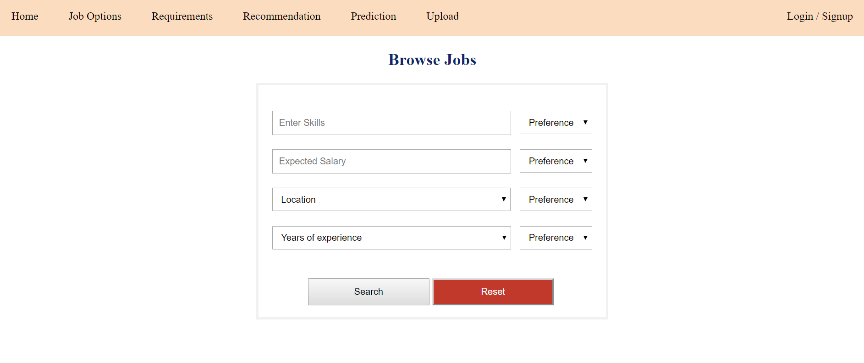

* They can also choose preference for sorting of results. The results will show job title, job description, requirements, salary, location (please refer to flowchart)

For example they enter **python** as skills and location **kuala lumpur**. The user sets skills as preference number 2 and location as preference number 1. So, when the results show they need to sorted as jobs in kuala lumpur with python skills should be on top and then jobs in kuala lumpur with similar skills should be second *(because location is priority/preference number 1)* and then jobs with python skills in other location will show next.

* What I mean by similar skills? – For example, if a user searches for jobs with JAVA skills, results should also show JAVA, C++, Python etc because they all are object-oriented programming. **(For this I suggest to please use sql statements. If Skills LIKE Java, then…)**

The pages are **DONE** and connected to database (which has **jobs** table with job listings in it), but the search function doesn’t work according to how I want it. I just want the search function to work and I want simple coding (nothing too complicated) because I have to understand the codes and present it to my Viva Panel. (the search function should use Keyword matching)

**Employers Part (Searching Candidates)**

* Employer Sign up/Login
* After login employers will go to **Search Candidates** page to search for candidates with their required skills.
* They can also choose preference for sorting of results. The results will show candidates name, email, skills, years of experience, address (refer to flowchart)
* The results function will work same as employees part. So, when an employer searches for candidates with python skills, the results will show candidates with python skills and also show candidates with similar skills (java, C++ etc).
* The sorting function is also same, sorted according to preference.

The pages are not yet for employers part but it’s pretty much the same thing. So if you think these pages are going to cost me extra, I’ll try to do them myself first :) I just need the search function mainly to work exactly how I explained.